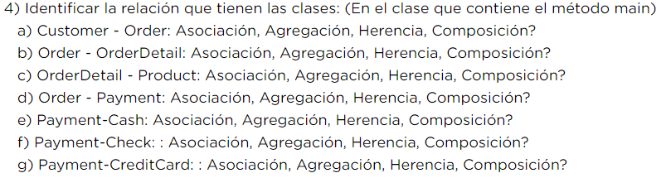

RPTA:

1. Customer - Order: Asociación
2. Order - OrderDetail: , Composición
3. OrderDetail - Product:
4. Order - Payment:
5. Payment-Cash: herencia
6. Payment-Check: : herencia
7. Payment-CreditCard: : Herencia